EMPLOYEE PERFORMANCE MAPPING
- Create a database named employee, then import data_science_team.csv proj_table.csv and emp_record_table.csv into the employee database from the given resources.

CREATE DATABASE employee;
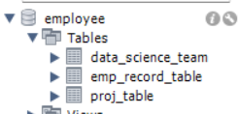

- Create an ER diagram for the given employee database.
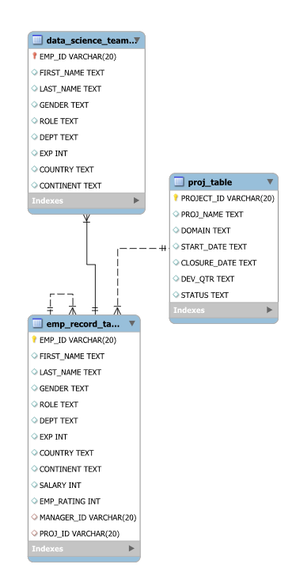

- Write a query to fetch EMP_ID, FIRST_NAME, LAST_NAME, GENDER, and DEPARTMENT from the employee record table, and make a list of employees and details of their department

SELECT EMP_ID, FIRST_NAME, LAST_NAME, GENDER, DEPT AS DEPARTMENT
FROM emp_record_table;
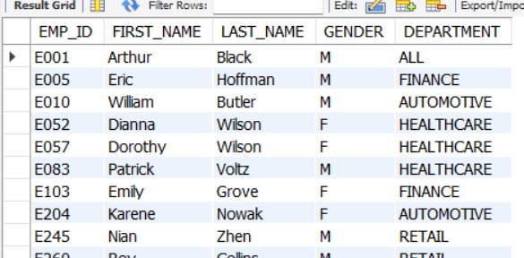
4. Write a query to fetch EMP_ID, FIRST_NAME, LAST_NAME, GENDER, DEPARTMENT, and EMP_RATING if the EMP_RATING is:
● less than two
● greater than four
● between two and four
SELECT
EMP_ID,
FIRST_NAME,
LAST_NAME,
GENDER,
DEPT AS DEPARTMENT,
EMP_RATING,
CASE
WHEN EMP_RATING < 2 THEN 'Less than 2'
WHEN EMP_RATING > 4 THEN 'Greater than 4'
WHEN EMP_RATING BETWEEN 2 AND 4 THEN 'Between 2 and 4'
END AS RATING_CATEGORY
FROM emp_record_table;
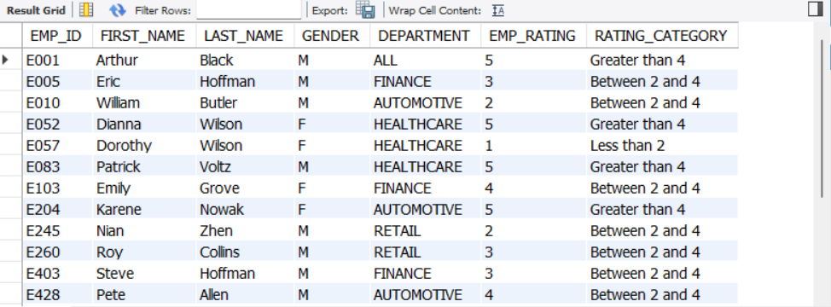
- Write a query to concatenate the FIRST_NAME and the LAST_NAME of employees in the Finance department from the employee table and then give the resultant column alias as NAME.

SELECT CONCAT(FIRST_NAME, ' ', LAST_NAME) AS NAME
FROM emp_record_table
WHERE DEPT = 'FINANCE';
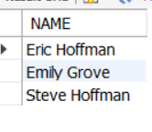
- Write a query to list only those employees who have someone reporting to them. Also, show the number of reporters (including the President).
SELECT m.EMP_ID,
m.FIRST_NAME,
m.LAST_NAME,
m.ROLE,
COUNT(e.EMP_ID) AS NUMBER_OF_REPORTERS
FROM emp_record_table AS m
JOIN emp_record_table AS e
ON m.EMP_ID = e.MANAGER_ID
GROUP BY m.EMP_ID,
m.FIRST_NAME,
m.LAST_NAME,
m.ROLE;
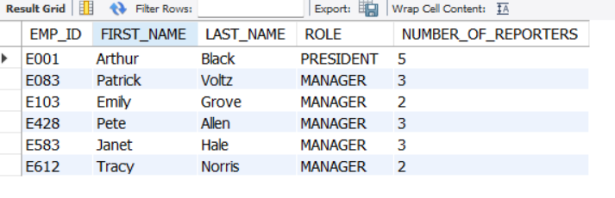
- Write a query to list down all the employees from the healthcare and finance departments using union. Take data from the employee record table.

SELECT *
FROM emp_record_table
WHERE DEPT = 'HEALTHCARE'
UNION

SELECT *
FROM emp_record_table
WHERE DEPT = 'FINANCE';
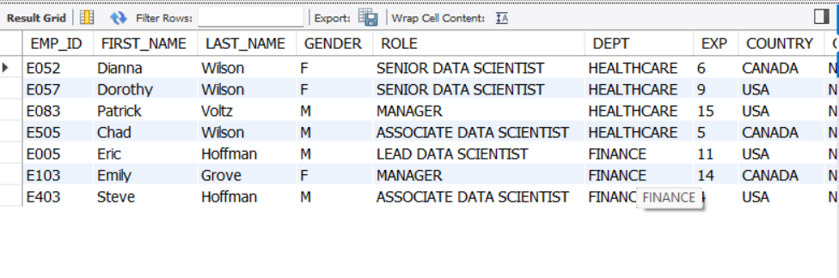
- Write a query to list down employee details such as EMP_ID, FIRST_NAME, LAST_NAME, ROLE, DEPARTMENT, and EMP_RATING grouped by dept. Also include the respective employee rating along with the max emp rating for the department.
SELECT EMP_ID,
FIRST_NAME,
LAST_NAME,
ROLE,
DEPT AS DEPARTMENT,
EMP_RATING,
MAX(EMP_RATING) OVER (PARTITION BY DEPT) AS MAX_DEPT_RATING
FROM emp_record_table
ORDER BY DEPT;
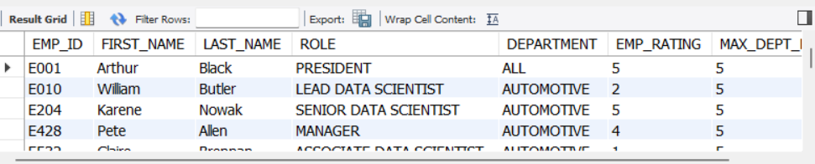
- Write a query to calculate the minimum and the maximum salary of the employees in each role. Take data from the employee record table
SELECT ROLE,
MIN(SALARY) AS MIN_SALARY,
MAX(SALARY) AS MAX_SALARY
FROM emp_record_table
GROUP BY ROLE;
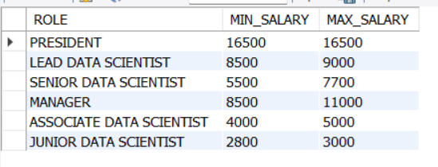

- Write a query to assign ranks to each employee based on their experience. Take data from the employee record table.
SELECT EMP_ID,
FIRST_NAME,
LAST_NAME,
EXP,
RANK() OVER (ORDER BY EXP DESC) AS EXPERIENCE_RANK
FROM emp_record_table;
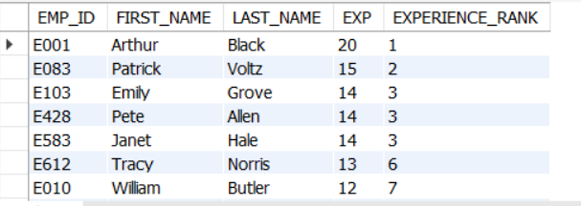

- Write a query to create a view that displays employees in various countries whose salary is more than six thousand. Take data from the employee record table
CREATE VIEW employee_country_salary AS
SELECT EMP_ID,
FIRST_NAME,
LAST_NAME,
COUNTRY,
SALARY
FROM emp_record_table
WHERE SALARY > 6000;

SELECT *
FROM employee_country_salary;

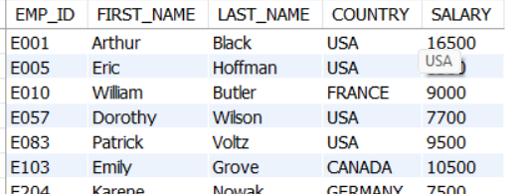

- Write a nested query to find employees with experience of more than ten years. Take data from the employee record table.
SELECT *
FROM emp_record_table
WHERE EMP_ID IN (
SELECT EMP_ID
FROM emp_record_table
WHERE EXP > 10
);
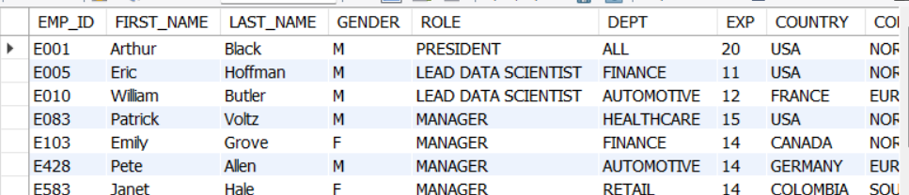

- Write a query to create a stored procedure to retrieve the details of the employees whose experience is more than three years. Take data from the employee record table.
DELIMITER //

CREATE PROCEDURE GetExperiencedEmployees()
BEGIN
SELECT *
FROM emp_record_table
WHERE EXP > 3;
END //

DELIMITER ;

- Write a query using stored functions in the project table to check whether the job profile assigned to each employee in the data science team matches the organization’s set standard. The standard being: For an employee with experience less than or equal to 2 years assign 'JUNIOR DATA SCIENTIST', For an employee with the experience of 2 to 5 years assign 'ASSOCIATE DATA SCIENTIST', For an employee with the experience of 5 to 10 years assign 'SENIOR DATA SCIENTIST', For an employee with the experience of 10 to 12 years assign 'LEAD DATA SCIENTIST', For an employee with the experience of 12 to 16 years assign 'MANAGER'.
DELIMITER //

CREATE FUNCTION GetStandardRole(experience INT)
RETURNS VARCHAR(50)
DETERMINISTIC
BEGIN
DECLARE standard_role VARCHAR(50);

IF experience <= 2 THEN
SET standard_role = 'JUNIOR DATA SCIENTIST';
ELSEIF experience <= 5 THEN
SET standard_role = 'ASSOCIATE DATA SCIENTIST';
ELSEIF experience <= 10 THEN
SET standard_role = 'SENIOR DATA SCIENTIST';
ELSEIF experience <= 12 THEN
SET standard_role = 'LEAD DATA SCIENTIST';
ELSEIF experience <= 16 THEN
SET standard_role = 'MANAGER';
ELSE
SET standard_role = 'NOT DEFINED';
END IF;

RETURN standard_role;
END //

DELIMITER ;

SELECT EMP_ID,
FIRST_NAME,
LAST_NAME,
EXP,
ROLE AS CURRENT_ROLE,
GetStandardRole(EXP) AS STANDARD_ROLE,
CASE
WHEN ROLE = GetStandardRole(EXP) THEN 'MATCH'
ELSE 'NOT MATCH'
END AS ROLE_STATUS
FROM data_science_team;
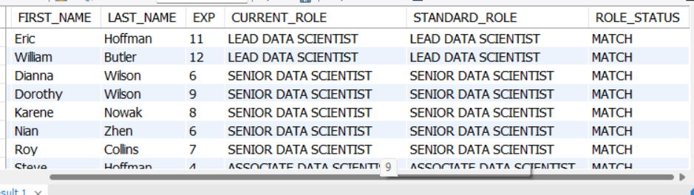

- Create an index to improve the cost and performance of the query to find the employee whose FIRST_NAME is ‘Eric’ in the employee table after checking the execution plan.
CREATE INDEX idx_first_name
ON emp_record_table(FIRST_NAME(20))
EXPLAIN
SELECT *
FROM emp_record_table
WHERE FIRST_NAME = 'Eric';

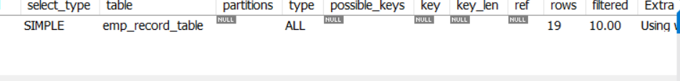

- Write a query to calculate the bonus for all the employees, based on their ratings and salaries (Use the formula: 5% of salary * employee rating).

SELECT EMP_ID,
FIRST_NAME,
LAST_NAME,
SALARY,
EMP_RATING,
(SALARY * 0.05 * EMP_RATING) AS BONUS FROM eeemp_record_table;
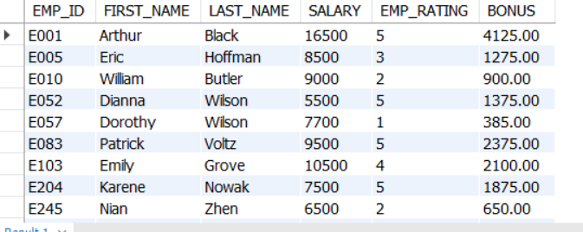
17) Write a query to calculate the average salary distribution based on the continent and country. Take data from the employee record table.
SELECT CONTINENT,
COUNTRY,
AVG(SALARY) AS AVG_SALARY
FROM emp_record_table
GROUP BY CONTINENT, COUNTRY
ORDER BY CONTINENT, COUNTRY;
